**TABLE OF CONTENTS**

|  |  |  |
| --- | --- | --- |
| **S. No.** | **Title** | **Page No.** |
| 1 | Declaration | 2 |
| 2 | Certificate of Originality | 3 |
| 3 | Acknowledgemnt | 4 |
| 4 | Objective | 6 |
| 5 | Introduction | 7 |
| 6 | Business Problem | 9 |
| 7 | Software Requirement Specification (SRS) | 14 |
| 8 | Project Description | 20 |
| 9 | SQL Queries | 25 |
| 10 | Analysis & Findings | 26 |
| 11 | Business Suggestions | 27 |
| 12 | Conclusion |  |
| 13 | Bibliography/References |  |

# OBJECTIVE

The objective of this project is to analyze pizza sales data to derive actionable insights, identify customer preferences, and optimize sales strategies. Using MySQL for data querying and Power BI for visualization, we aim to understand sales trends, peak hours, best-selling products, and revenue distribution across different categories. These insights will be used to make data-driven business decisions for improved marketing, inventory management, and customer engagement.

#### Key Metrices of Focus:

* Sales trends
* Peak hours
* Best-selling products
* Revenue distribution

#### Project Significance:

Understanding customer behavior and sales trends is essential for success in the competitive food and beverage industry. For a pizza business, knowing which products are best-sellers, the peak times for orders, and revenue contributions by category can make a substantial difference in profitability and operational efficiency. This project focuses on leveraging data analytics to gain actionable insights from sales data using Power BI and MySQL.

By conducting a detailed analysis of pizza sales data, the project aims to address key business questions:

Which pizzas are the most and least popular?

When are the peak sales periods during the week and day?

What is the revenue distribution across different pizza categories and sizes? How can marketing strategies be optimized based on data-driven insights?

These insights are crucial for making informed decisions on inventory management, marketing, pricing, and overall business strategy.

# INTRODUCTION

The food and beverage industry is highly competitive, and understanding customer preferences is crucial for success. This project focuses on a detailed analysis of pizza sales data, providing insights into sales trends, peak order times, popular pizza types, and revenue patterns. Using MySQL for data management and Power BI for creating interactive dashboards, this analysis presents data-driven insights that can help improve business performance.

#### The report covers:

* Sales performance over different time frames (daily, weekly, and monthly).
* Analysis of the most popular pizza types and sizes.
* Insights into peak sales periods.
* Recommendations for optimizing marketing and inventory management.

#### Analytical Approach:

The analytical approach for this project involves several systematic steps:

#### Data Collection and Preparation:

* + Collect data from various sources including order details, pizza categories, sales records, and customer information. The data is imported from CSV files into a MySQL database.
  + Clean and preprocess the data to ensure consistency, handle missing values, and remove duplicates. This step is crucial for accurate analysis.
  + Integrate different datasets, such as pizza types, sizes, and sales information, to create a comprehensive view of sales performance.

#### Data Exploration Using SQL:

* + Use SQL queries to explore the data and retrieve specific insights. Queries will be executed to calculate total sales, identify the most popular pizzas, analyze peak sales hours, and examine revenue distribution by category.
  + Examples of SQL queries include:
  + Total Revenue Calculation:

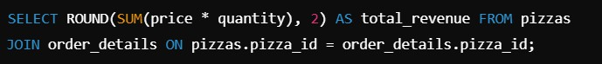

* + Identifying Top-Selling Pizzas:

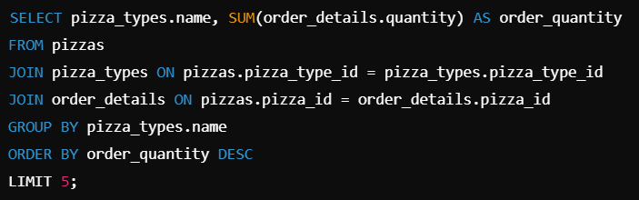

#### Data Analysis and Visualization:

* + Use the extracted data to perform in-depth analysis. Focus on key metrics such as total orders, revenue generation, and customer buying patterns.
  + Employ Power BI for visualizing the analyzed data, making it easier to interpret complex datasets and derive actionable insights.

#### Insights Generation and Recommendations:

* + Derive insights from the visualizations to understand which products are performing well and identify areas for improvement.
  + Provide recommendations based on data analysis to optimize sales, marketing strategies, and inventory management.

#### Visualization Strategy with Power BI

Power BI was chosen for its robust data visualization capabilities, allowing for interactive and dynamic dashboards that present data insights in an intuitive manner. The visualization strategy focuses on using various Power BI features to create clear, insightful, and easy-to-navigate reports:

#### Interactive Dashboards:

* + Sales Performance Dashboard: Shows overall sales performance, including key metrics like total revenue, total orders, and average order value.
  + Product Analysis Dashboard: Displays sales and revenue by product, highlighting top-selling and underperforming pizzas.
  + Time-Based Trends Dashboard: Visualizes sales patterns across different times (days, weeks, months), helping identify peak order periods.

#### Use of Different Visualization Types:

* + Line Charts: depict sales trends over time, highlighting fluctuations in sales volume across months or weeks.
  + Bar Charts: To compare sales and revenue for different pizza types, sizes, and categories. This helps in quickly identifying the most and least popular products.
  + Pie Charts: To show the percentage distribution of sales across different categories (e.g., Classic, Supreme, Veggie, Chicken).
  + Heatmaps: To display sales density by hour and day, allowing identification of peak sales times. Useful for staffing and promotional planning.
  + Stacked Bar Charts: To illustrate revenue breakdown by product category, providing a visual comparison of how each category contributes to the total sales.

#### Dynamic Filters and Slicers:

* + Date Range Filters: Enable users to adjust the time range (daily, weekly, monthly, quarterly) to analyze trends over specific periods.
  + Category Filters: Allow users to filter data by pizza category (e.g., Classic, Supreme) or size (Small, Medium, Large).
  + Geographic Filters (Optional): If there are multiple store locations, map visualizations can show regional performance.

#### Dashboard Layout and User Experience:

* + The dashboards are designed to be user-friendly, with a logical layout that guides users from high-level summaries to more detailed insights.
  + Each dashboard is equipped with tooltips and data labels, providing additional context without overwhelming the visuals.

#### Charting Insights:

The use of charts in this project is critical for effectively communicating data insights. Here are some examples of charting insights that can be derived:

#### Sales Trends Over Time:

* + Insight: Identify months with peak sales, helping to understand seasonal trends or the impact of marketing campaigns.
  + Visualization: Line chart showing monthly sales volumes.

#### Product Popularity:

* + Insight: Top-selling pizzas can be highlighted, allowing the business to focus marketing efforts on these products. Identify underperforming items for potential removal or rebranding.
  + Visualization: Bar charts comparing the number of orders for different pizza types.

#### Revenue Contribution:

* + Insight: Understanding which pizza categories contribute the most to revenue helps allocate resources efficiently.
  + Visualization: Stacked bar charts showing revenue from each category.

#### Hourly and Weekly Sales Patterns:

* + Insight: Determine the busiest times of the day and week. This helps in staffing decisions, inventory stocking, and planning special offers to boost sales during off-peak times.
  + Visualization: Heatmap showing sales distribution across hours and days.

#### Customer Purchase Behavior:

* + Insight: Analyze average order sizes and popular pizza combinations, helping to create effective combo deals and upselling strategies.
  + Visualization: Pie charts and histograms to show the distribution of order sizes and combinations.

#### Project Significance:

The ability to make informed, data-driven decisions can significantly improve a business’s profitability, especially in the competitive food industry. This project leverages data analytics to provide a clear view of sales performance, helping businesses to:

* + Maximize Revenue: By identifying top-performing products and peak sales periods, the business can focus its efforts on revenue-generating strategies.
  + Improve Marketing Efficiency: Marketing campaigns can be tailored based on insights, ensuring that promotions reach the right customers at the right times.
  + Optimize Operations: Understanding sales trends helps in planning staffing and

inventory management, leading to reduced waste and operational costs.

* + Enhance Customer Satisfaction: By recognizing customer preferences and purchase patterns, the business can tailor its offerings to meet demand, improving customer satisfaction and loyalty.

Overall, this project aims to transform raw sales data into actionable insights, enabling the business to make strategic decisions that drive growth and profitability.

# CONTENT

#### pizza_id

Description: A unique identifier for each individual pizza.

Purpose: Helps differentiate between various pizzas in the dataset, used to track specific pizza orders and relate them to order details.

#### order_id

Description: A unique identifier for each customer order.

Purpose: Links each pizza in the dataset to a specific customer order, allowing for multi-pizza orders to be grouped together under one transaction.

#### pizza_name_id

Description: An identifier that represents the name of the pizza.

Purpose: Links each pizza to its corresponding name in the pizza catalog, helping to group pizzas by name for analysis (e.g., total orders of "Classic Deluxe").

#### quantity

Description: The number of units of each pizza ordered in a specific transaction.

Purpose: Used to calculate the total number of pizzas sold in each transaction, and across all transactions, for reporting and inventory management.

#### order_date

Description: The specific date on which the order was placed.

Purpose: Allows for time-based analysis of sales patterns, such as identifying busy periods or seasonal trends.

#### order_time

Description: The exact time when the order was placed.

Purpose: Useful for determining peak order hours, helping businesses optimize staffing and delivery schedules.

#### unit_price

Description: The price for a single unit of the ordered pizza.

Purpose: Used to calculate the total revenue per pizza type, as well as to analyze pricing strategies and customer purchasing behavior.

#### total_price

Description: The total price of all pizzas in the order, based on the quantity and unit price.

Purpose: Key metric for determining total revenue from each order and analyzing overall financial performance.

#### pizza_size

Description: The size of the pizza ordered (e.g., small, medium, large). Purpose: Helps in analyzing sales distribution across pizza sizes, aiding in inventory management and promotional strategies for different sizes.

#### pizza_category

Description: The category or type to which the pizza belongs (e.g., Classic, Veggie, Chicken).

Purpose: Useful for analyzing sales patterns by pizza category, which helps determine which types of pizzas are more popular and contribute the most to revenue.

#### pizza_ingredients

Description: The list of ingredients used in the pizza.

Purpose: Helps in analyzing customer preferences based on pizza ingredients, as well as understanding inventory needs for specific ingredients.

#### pizza_name

Description: The actual name of the pizza (e.g., "Classic Deluxe").

Purpose: Provides a more intuitive understanding of the pizzas being analyzed, linking the name to order quantities and revenue generation.

#### Additional Columns:

* + - **Day Name**

Description: The name of the day of the week when the order was placed (e.g., Monday, Friday).

Purpose: Used for day-of-the-week analysis to identify which days have the highest number of orders, helping in workforce scheduling and promotional planning.

#### Order Day

Description: The day of the week (as a word, such as "Monday") when the order was placed.

Purpose: Similar to "Day Name," but focuses on aligning sales data with specific days for more refined analysis.

#### Day Number

Description: The numerical representation of the day of the week (e.g., 1 for Monday, 7 for Sunday).

Purpose: Useful for quick calculations and analysis when sorting or grouping data by days numerically, enabling easy identification of weekly trends.

#### Month Name

Description: The name of the month when the order was placed (e.g., January, August).

Purpose: Facilitates seasonal and monthly trend analysis, allowing businesses

to plan ahead for high-demand months.

#### Month Number

Description: The numerical representation of the month (e.g., 1 for January, 12 for December).

Purpose: Useful for performing calculations or sorting data by month in chronological order for more structured analysis.

#### Order Month

Description: The month in which the order was placed, shown as a word (e.g., "January").

Purpose: Helps identify sales patterns over different months, which can guide marketing campaigns and product promotions.

# BUSINESS PROBLEM

#### Business Problem : Enhancing Pizza Sales Performance

In the competitive landscape of the pizza industry, our business faces the challenge of optimizing sales performance and maximizing revenue. To address this, we need to gain actionable insights from our pizza sales data. The key areas of focus include understanding customer behaviors, identifying popular pizza options, and recognizing factors influencing order trends.

#### KEYS REQUIREMENTS:

* Sales Variability: Sales are inconsistent, with higher volumes on weekends and lower on weekdays.
* Product Popularity: Understanding which pizzas are most and least popular is essential for inventory and marketing strategies.
* Revenue Optimization: Identifying products that generate the most revenue and those that underperform.
* Inventory Efficiency: Optimizing inventory based on sales patterns to reduce waste and costs.

By addressing these problems, the business can improve its profitability and customer satisfaction.

#### CHARTS REQUIREMENTS

* **Total Sales by Pizza Category:** Use a Donut Chart to display the proportion of sales from different pizza categories (e.g., Classic, Supreme). This helps identify which categories are most popular.
* **Revenue by Pizza Size:** A Stacked Bar Chart can analyze revenue contributions from each pizza size, segmented by category, to understand size-based sales dynamics.
* **Monthly Sales Trend:** A Line Chart will track total sales over months, revealing seasonal patterns and growth trends.
* **Daily Sales Breakdown:** A Column Chart can show sales distribution across the week, helping to pinpoint peak sales days.
* **Hourly Sales Analysis:** A Heatmap or Line Chart will visualize sales trends by hour, assisting in staffing and inventory decisions.
* **Best-Selling Pizzas:** A Bar Chart can highlight the top-selling pizzas based on quantity sold, informing promotional strategies.
* **Sales by Pizza Type and Size:** A Clustered Bar Chart compares the popularity of various pizza types and sizes.
* **Ingredient Popularity:** Utilize a Word Cloud to visualize commonly used ingredients, aiding inventory management.
* **Sales Growth Rate:** A Line Chart can track sales growth over time, providing insights into business performance.
* **Average Order Value by Day:** A KPI Indicator can reveal how average order values change by day, supporting pricing strategies.
* **Customer Segmentation Analysis:** A Treemap or Bar Chart can display revenue contributions from different customer segments.
* **Cumulative Sales Over Time:** An Area Chart visualizes total sales accumulation, highlighting overall growth trend

# Software Requirement Specification (SRS)

* Power BI: For creating interactive dashboards and visualizations.
* MySQL: For data storage, retrieval, and analysis using SQL queries.
* Data Files: CSV files containing data on pizzas, orders, and sales.
* Microsoft Excel: For data manipulation and export.

#### System Requirements

* Operating System: Windows 10 or higher.
* RAM: At least 8GB.
* Database Software: MySQL 5.7 or higher.
* Power BI: Latest version for best features and compatibility.

# DESCRIPTION

#### Objective

The objective of this project is to analyze pizza sales data to gain actionable insights into customer preferences, sales trends, and overall business performance. By leveraging Power BI for visualization and MySQL for data management, the project aims to identify key factors influencing sales, optimize inventory, and enhance marketing strategies to drive revenue growth.

#### Dataset Overview

The dataset used in this analysis includes multiple tables and files containing comprehensive information on pizza sales transactions. Key components of the dataset include:

* Pizza Sales Data: Contains details such as order_id, pizza_id, pizza_name, quantity, order_date, order_time, unit_price, and total_price.
* Pizza Types: A catalog of available pizzas, including pizza_category, pizza_size, and pizza_ingredients.
* Temporal Data: Additional fields for analytical purposes, including Day Name, Month Name, and Order Day, which facilitate time-based analysis of sales trends.
* This dataset enables a thorough examination of sales performance across different dimensions, such as time, product type, and customer preferences.

#### Key Performance Indicators (KPIs)

To measure the success of the pizza sales analysis, several key performance indicators (KPIs) will be tracked, including:

* Total Revenue: Total income generated from pizza sales over a specified period.
* Total Orders: The total number of orders placed during the analysis period.
* Average Order Value (AOV): Calculated as total revenue divided by total orders, providing insights into customer spending behavior.
* Sales Growth Rate: Percentage increase in sales over time, indicating business growth.
* Best-Selling Pizza Types: Identifying which pizzas generate the most sales volume, assisting in inventory and marketing decisions.
* Peak Sales Hours/Days: Times or days of the week when sales are highest, allowing for optimized staffing and promotional strategies.

#### Charting Insights

The analysis will utilize various charts to visualize data and derive insights, including:

* Donut Chart: Showing total sales by pizza category to identify the most popular categories.
* Stacked Bar Chart: Analyzing revenue by pizza size, segmented by category.
* Line Chart: Tracking monthly sales trends to identify seasonal patterns.
* Column Chart: Displaying daily sales distribution to pinpoint peak sales days.
* Heatmap: Visualizing hourly sales patterns to determine busy hours.

These charts will facilitate a clear understanding of sales performance and trends, enhancing the ability to make data-driven decisions.

#### Business Objectives

The primary business objectives of this project include:

* Enhancing Customer Satisfaction: By understanding preferences and trends, the business can tailor offerings to meet customer needs.
* Optimizing Inventory Management: Identifying best-selling pizzas will help ensure adequate stock levels and reduce waste.
* Improving Marketing Strategies: Targeted promotions can be developed based on sales trends and customer preferences, boosting sales and customer loyalty.
* Increasing Revenue: By analyzing and acting upon insights from sales data, the business aims to drive overall revenue growth.

#### Expected Outcomes

The expected outcomes of the pizza sales analysis project include:

* Comprehensive Insights: A detailed understanding of sales patterns, customer preferences, and product performance.
* Actionable Recommendations: Data-driven strategies for marketing, inventory management, and product offerings that align with customer demand.
* Informed Decision-Making: Enhanced ability for management to make strategic decisions based on accurate and visually represented data analysis.
* Revenue Growth: Ultimately, the insights gained will contribute to increasing overall sales and profitability for the pizza business.

# PIZZA SALES SQL QUERIES

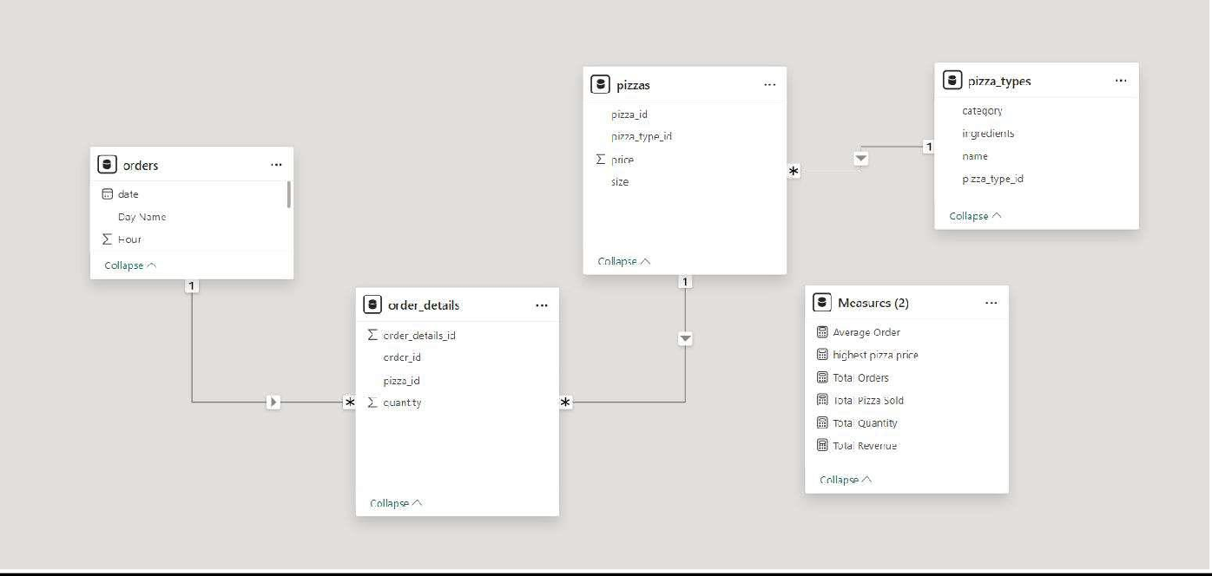**Data Flow Diagram:**

### Retrieve the total number of orders placed.

select count(order_id) as total_orders from orders

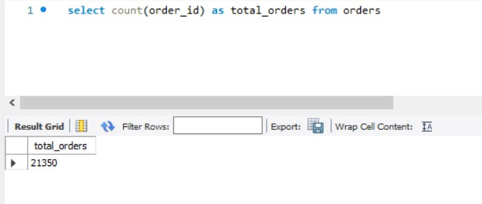

### Calculate the total revenue generated from pizza sales.

select round(sum(price*quantity),2) as total_revenue from pizzas join order_details

on pizzas.pizza_id = order_details.pizza_id

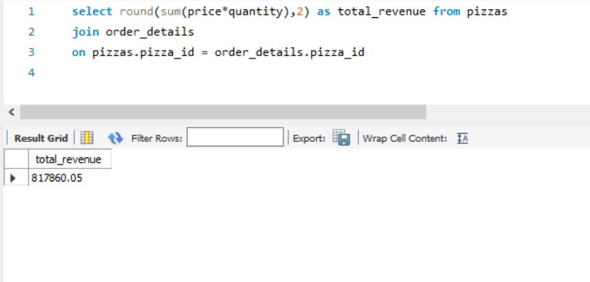

### Identify the highest-priced pizza.

select pizza_types.name, pizzas.price from pizzas join pizza_types

on pizzas.pizza_type_id = pizza_types.pizza_type_id order by pizzas.price desc

limit 1

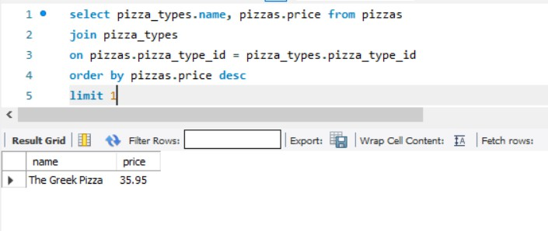

### Identify the most common pizza size ordered.

select pizzas.size, count(order_details.order_details_id) as order_count from pizzas

join order_details

on pizzas.pizza_id = order_details.pizza_id group by pizzas.size

order by order_count desc

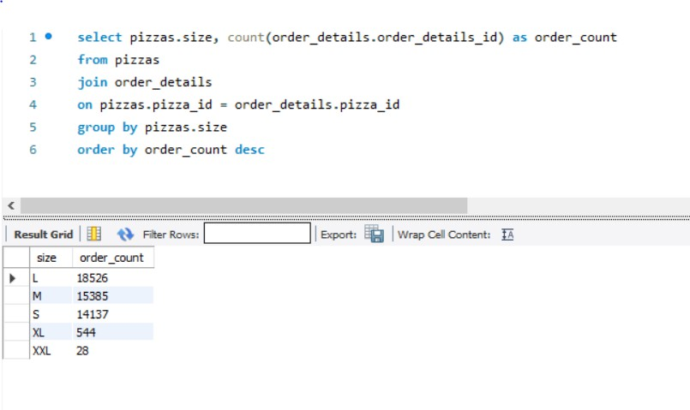

### List the top 5 most ordered pizza types along with their quantities.

select pizza_types.name, sum(order_details.quantity) as order_quantity from pizzas

join pizza_types

on pizzas.pizza_type_id = pizza_types.pizza_type_id join order_details

on pizzas.pizza_id = order_details.pizza_id group by pizza_types.name

order by order_quantity desc limit 5

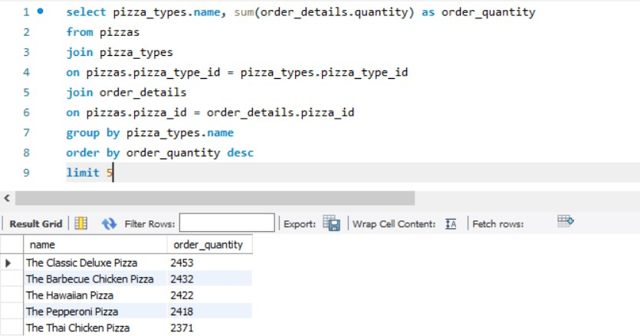

### Join the necessary tables to find the total quantity of each pizza category ordered.

select pizza_types.category, sum(order_details.quantity) as order_quantity from pizzas

join pizza_types

on pizzas.pizza_type_id = pizza_types.pizza_type_id join order_details

on pizzas.pizza_id = order_details.pizza_id group by pizza_types.category

order by order_quantity desc

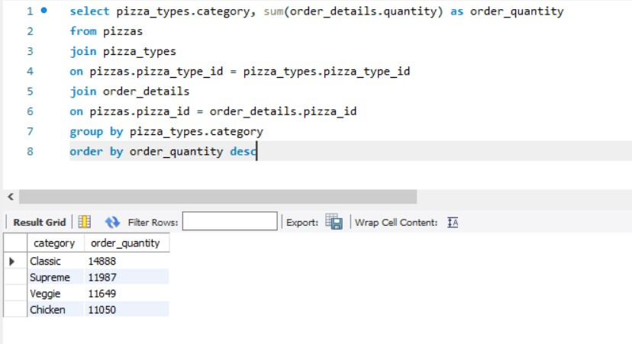

### Determine the distribution of orders by hour of the day.

select hour(order_time), count(order_id) 'No._of_order' from orders group by hour(order_time)

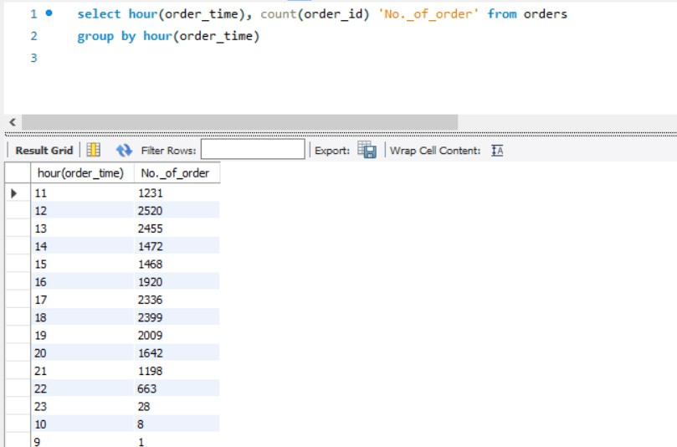

### Join relevant tables to find the category-wise distribution of pizzas.

select category, count(name) as count from pizza_types group by category

order by count desc

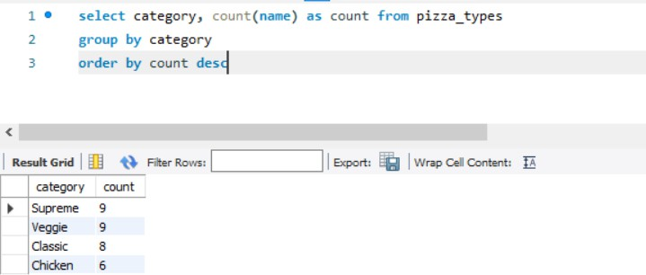

### Group the orders by date and calculate the average number of pizzas ordered per day.

select Round(avg(total_order_quantity),0) from

(select orders.order_date, sum(order_details.quantity) as total_order_quantity

from orders

join order_details

on orders.order_id = order_details.order_id group by orders.order_date)

as order_per_day

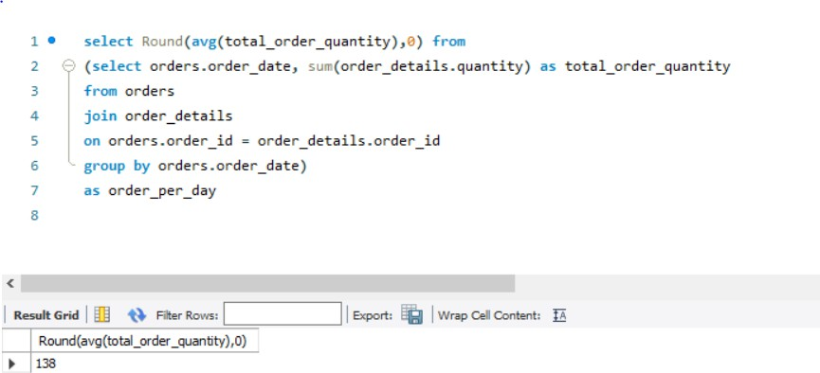

### Determine the top 5 most ordered pizza types based on revenue.

select pizza_types.name, sum(order_details.quantity*pizzas.price) as revenue from pizzas

join pizza_types

on pizzas.pizza_type_id = pizza_types.pizza_type_id join order_details

on pizzas.pizza_id = order_details.pizza_id group by pizza_types.name

order by revenue desc limit 5

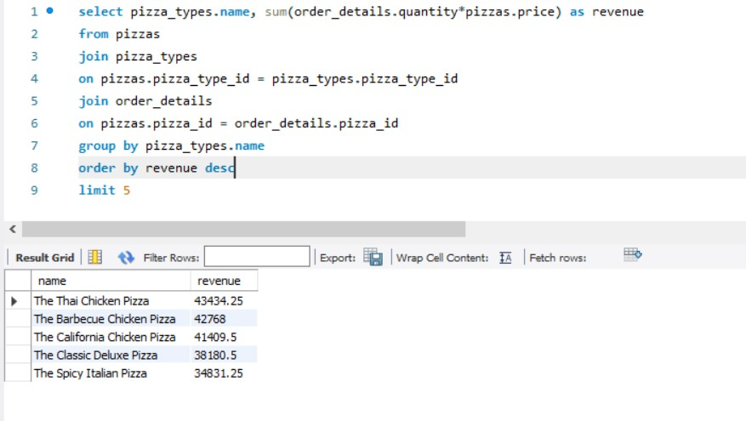

### Calculate the percentage contribution of each pizza type to total revenue.

select pizza_types.category,

round(sum(order_details.quantity*pizzas.price) / (select round(sum(order_details.quantity*pizzas.price),2) as total_sales

from order_details join pizzas

on pizzas.pizza_id = order_details.pizza_id) * 100,2) as revenue from pizzas

join pizza_types

on pizzas.pizza_type_id = pizza_types.pizza_type_id join order_details

on pizzas.pizza_id = order_details.pizza_id group by pizza_types.category

order by revenue desc

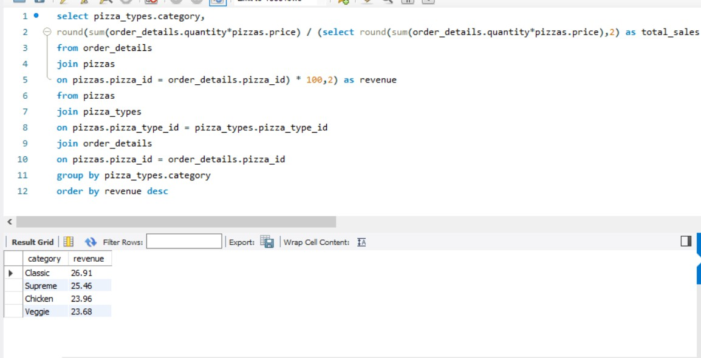

### Analyze the cumulative revenue generated over time.

select order_date, sum(revenue) over(order by order_date) as cum_revenue from

(select orders.order_date, sum(order_details.quantity * pizzas.price) as revenue from order_details

join pizzas

on pizzas.pizza_id = order_details.pizza_id join orders

on orders.order_id = order_details.order_id group by orders.order_date) as sales

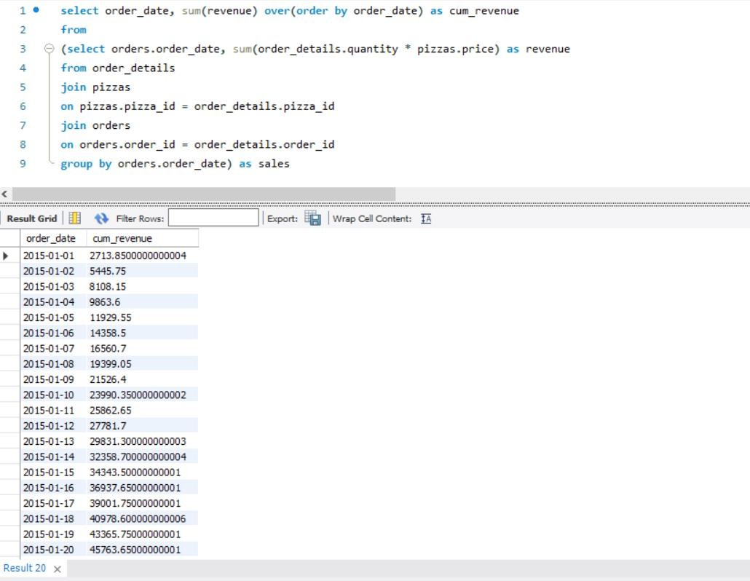

### Determine the top 3 most ordered pizza types based on revenue for each pizza category.

select name, revenue, ranking_by_category from (select name, category, revenue,

rank() over(partition by category order by revenue desc) as ranking_by_category from

(

select pizza_types.name, pizza_types.category, sum((order_details.quantity) * pizzas.price) as revenue from pizza_types

join pizzas

on pizza_types.pizza_type_id = pizzas.pizza_type_id join order_details

on order_details.pizza_id = pizzas.pizza_id group by pizza_types.category, pizza_types.name

) as order_table ) as b

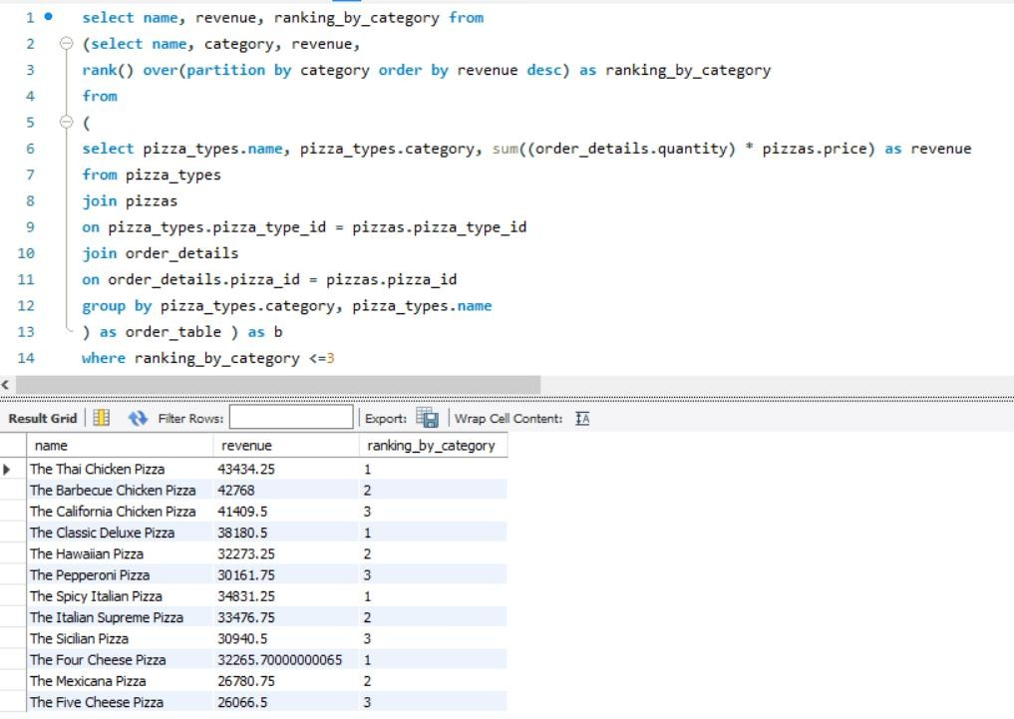where ranking_by_category <=3

# ANALYSIS AND FINDINGS

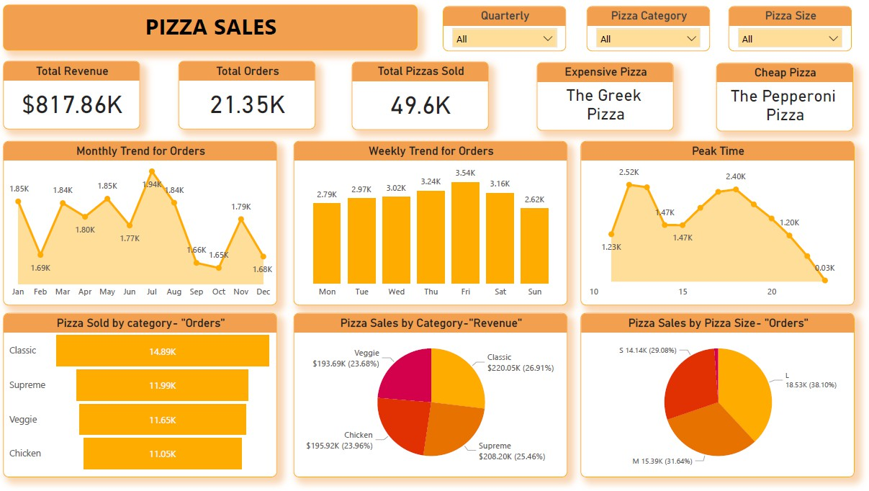

#### Monthly Sales Trends

* Visualization: Line graph showing sales trends over 12 months.
* Findings: Consistent sales with slight peaks in March and November. Promotions during these months could further increase sales.

#### Weekly and Daily Analysis

* Visualization: Heatmap showing order density by day and hour.
* Findings: Sales peak on weekends, especially around dinner time. Weekday promotions could help balance order volumes throughout the week.

#### Product Performance

* Top Performing: "The Classic Deluxe Pizza" and "The Barbecue Chicken Pizza" are the most ordered.
* Least Performing: Specialty pizzas like "The Mediterranean Pizza" have low sales, suggesting a potential need for rebranding or removal from the menu.

#### Revenue Insights

* Visualization: Stacked bar chart showing revenue by pizza category.
* Findings: Classic pizzas account for the highest revenue, followed by Supreme and Chicken. This insight can guide future product launches.

#### Inventory Recommendations

* Findings: Popular pizzas like "Classic Deluxe" should have a consistent supply of ingredients to avoid shortages. Ingredients for less popular pizzas can be managed to reduce waste.

# BUSINESS SUGGESTIONS

* **Weekday Promotions:** Encourage sales on slower days by offering discounts or special deals to boost weekday traffic.
* **Focus on Popular Pizzas:** Increase marketing efforts for top-performing pizzas to maximize sales.
* **Optimize Inventory Management:** Use sales data to forecast demand and ensure the right inventory levels, minimizing wastage.
* **Upselling Medium Pizzas:** Since medium pizzas are the most popular, introduce deals to encourage upselling (e.g., "Upgrade to a Large for $2 more").

# CONCLUSION

The analysis has revealed valuable insights into sales trends, customer preferences, and revenue generation. By leveraging these insights, the business can implement targeted marketing strategies, improve inventory management, and boost overall sales. Utilizing MySQL and Power BI effectively translates data into actionable business intelligence, leading to informed decision-making.

As we embark on this journey of data-driven decision-making, we position ourselves not just as a pizzeria but as a dynamic and responsive culinary destination. This project is not merely a study in numbers; it is a roadmap for our business's evolution and sustained success in the vibrant and competitive landscape of the pizza industry. The insights gained are not static conclusions but catalysts for ongoing innovation, adaptation, and a commitment to delivering the most satisfying pizza experience to our valued customers.

Armed with these insights, our business is poised to take targeted action. From optimizing underperforming items to strategically promoting best-sellers, we have the tools to refine our offerings. Menu adjustments, bundling strategies, and customer engagement initiatives are on the horizon, ensuring that we not only meet but exceed customer expectations.

# BIBLIOGRAPHY

* Data Sources: Pizza sales datasets (CSV files).
* Tools Documentation: Official Power BI and MySQL documentation.
* Industry Reports: Insights on market trends and consumer behavior in the food industry.